# SuperDARN – Restocking the Radar Hut

This section provides instructions for the maintenance of the radar hut and inventory lists of its contents.

The radar hut consists of two compartments: The lobby and the radar room, separated by a door. The lobby contains most of the supplies, while the radar room contains the radar hardware and a cabinet of some smaller spare components, stationary and miscellaneous items.

## Emergency Supplies

The radar hut is located about 600 m from the base. This means that one can get stuck there if the weather changes abruptly and becomes unfavourable for traveling back to the base. Thus, the hut is stocked with emergency supplies for this eventuality. Supplies for medical emergencies are also necessary since the base is so far away.

It is the responsibility of the overwintering radar engineer to see that these supplies are always up to standard and not expired. See *Table 1*, *Table 2*, *Table 3*, and *Table 4* below for a comprehensive list of all supplies that need to be always in the radar hut:

Table . Food.

|  |  |  |
| --- | --- | --- |
| Item | Description | Quantity |
| Water | There is a dispenser in the hut. It needs to be cleaned and refilled regularly. | 20 liters |
| Canned food | A variety is preferable. Preferably instant meal type of things. Check expiry dates. | 10 cans |
| Instant soup | A variety is preferable. Check expiry dates. | 10 packs |
| Biscuits | Provitas, rusks, crackers, etc. Check expiry dates. | 4 packs |
| Fruit bars | A variety is preferable. Check expiry dates. | 1 box |
| Dried fruit | A variety is preferable. Check expiry dates. | 2 packs |
| Coffee | Instant coffee powder Check expiry date. | 500 g |
| Tea | Preferably Rooibos and English. Check expiry date. | 20 bags |
| Condensed milk | Sweetened. Check expiry dates. | 3 cans |
| Game | Energy drink for restoring electrolytes. Check expiry dates. | 1 can |

Table . Utensils.

|  |  |  |
| --- | --- | --- |
| Item | Description | Quantity |
| Electric kettle | Check that it’s in working condition. | 1 |
| Electric stove | Check that it’s in a working condition. | 1 |
| Plate | Check condition. | 1 |
| Cup | Check condition. | 1 |
| Other | Knife, fork, spoon, etc. | 1 |

Table . Bedding.

|  |  |  |
| --- | --- | --- |
| Item | Description | Quantity |
| Mattress | Check that it’s in working condition. | 1 |
| Sleeping bag | Check that it’s in a working condition. | 1 |
| Pillow | Check condition. | 1 |

Table . Medical.

|  |  |  |
| --- | --- | --- |
| Item | Description | Quantity |
| Medical aid kit | Give to doctor for restocking before takeover. | 1 |
| Sunscreen | Check quantities and expiration dates. | 2 tubes |
| Hand warmers | Unopened. Check expiry dates. | 4 pairs |

Furthermore, the fire extinguisher should also be checked on a regular basis. Make sure that the extinguisher is refilled during takeover when the DPW is servicing the rest of the fire extinguishers on base.

## Climbing Gear

Climbing gear for antenna maintenance is kept in the radar hut as well. This gear should be inspected on a regular basis according to standards provided during the working at heights training in Cape Town.

It is the responsibility of the overwintering radar engineer to ensure that the climbing gear is always ready to go and well maintained. See *Table 5*, *Table 6*, and *Table 7* for a list of all equipment that needs to be available.

Table . Rescue bag.

|  |  |  |
| --- | --- | --- |
| Item | Description | Quantity |
| Rescue bag | Give to doctor for restocking before takeover. | 1 |
| Dynamic climbing rope | Check quantities and expiration dates. | 1 |
| Ratchet or jag system | Unopened. Check expiry dates. | 1 |
| Descender | - | 1 |
| Temporary slings | - | 2 |
| Carabiners | Attached to the slings. | 4 |

Table . 2 Climbing sets.

|  |  |  |
| --- | --- | --- |
| Item | Description | Quantity |
| Helmet | Check that they’re in good condition. | 1 per set |
| Full harness | Inspect regularly. | 1 per set |
| Work belt | (Or 2 cow tails) Check condition. | 1 per set |
| Shock absorbing lanyard | Check condition. Use carabiners instead of hooks to prevent slipping off ladder rungs. | 1 per set |
| Carabiners | For any other gear/equipment needed. | 4 per set |

Table . Other.

|  |  |  |
| --- | --- | --- |
| Item | Description | Quantity |
| Big red bag | Contains climbing sets and spares. | 1 |
| Climbing hooks | Not used but could come in handy. | 4 |
| Descenders | Various types. | 4 |
| Ratchet | Spare for rescue set. | 1 |
| Shock absorbing lanyards | Various types and lengths. | 4 |
| Slings | Various lengths | 4 |
| Adjustable work belt | - | 1 |
| Carabiners | Spares | 5 |
| Jag system | Spare for rescue set. | 1 |
| Climbing sling | - | 1 |
| Helmet | Spare | 1 |

Otherwise, there are also a whole pile of old ropes removed from the radar that can be used as go-ropes. Be sure to take one with for climbing, this makes help from the ground much easier. *Figure 1* shows what a rescue set should look like and what it should include.

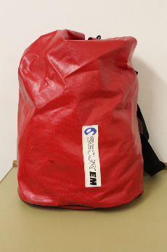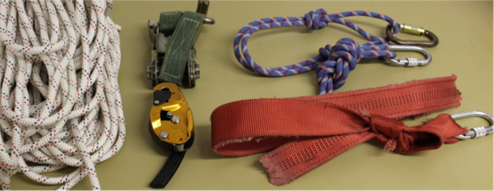

Figure . A rescue set and its content.

*Figure 2* shows what the climbing gear bag should look like and what it should include.

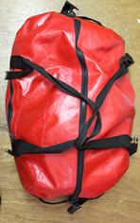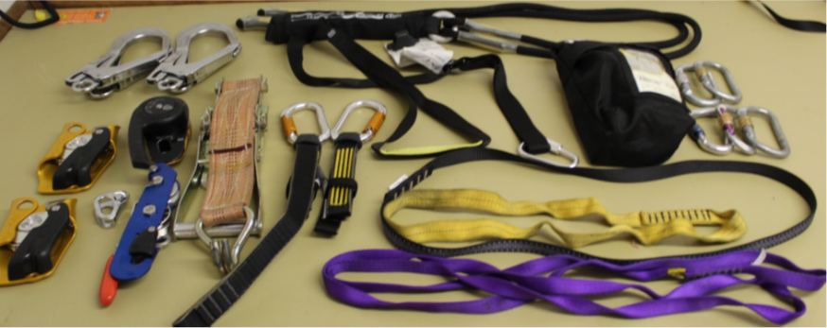

Figure . The climbing bag and its contents.

*Figure 3* shows what a climbing set should look like and what it should include. There are hooks in the radar hut where these can be hung to make it quicker to get ready for climbing.

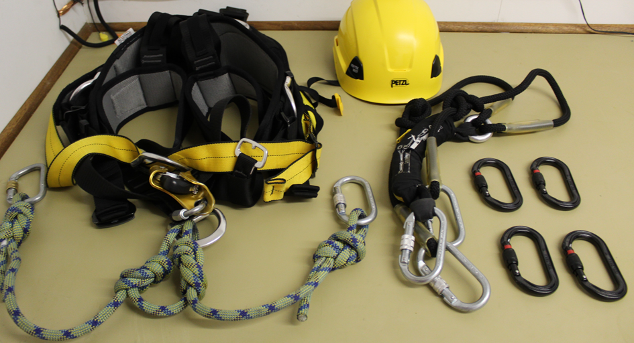

Figure . Gear a climbing set should include.

## Tools and Supplies

Any tools or materials necessary for routine maintenance on the radar should be available in the radar hut. If something breaks or is not available in the hut anymore, it should be added to the procurement list for the following takeover. Table 8, Table 9, and Table 10 shows a list of the tools and supplies.

Table . Tools.

|  |  |  |
| --- | --- | --- |
| Item | Description | Quantity |
| Tool bag | Complete tool set. | 1 |
| Spanner sets | Two complete sets, imperial and metric. (Blue bag) | 2 |
| Big spanners | Two complete sets of large spanners, imperial and metric. (Against wall) | 2 |
| Metal strapping tool | For fastening metal straps. | 1 |
| Metal strapping | For tying the cable to the radar masts. See that there’s enough. | 1 roll |
| Metal strapping sliders | For use with the metal straps. See that there’s enough. | 1 box |

Table . Cleaning supplies.

|  |  |  |
| --- | --- | --- |
| Item | Description | Quantity |
| Bucket | For cleaning. | 1 |
| Cloths | One for cleaning and one for dishes. | 2 |
| Mr Min | For cleaning and wood cabinet. | 1 |
| Dish Soap | For cleaning dishes. | 1 |
| Brush | For cleaning. | 1 |
| Broom | For sweeping every now and again. | 1 |

Table . Outside.

|  |  |  |
| --- | --- | --- |
| Item | Description | Quantity |
| Spade | For clearing snow. | 1 |
| Pry bar | For clearing hard ice. | 1 |

## Electricity

Electricity to the radar hut is supplied by the base. From there, it is also relayed to the Ozone Radiometer dome.

The power supplied to the radar is not on the base’s UPS. There is a small UPS in the radar hut, however *Figure 4*. This UPS only lasts about 5 minutes, just enough to properly switch off the radar. That means that the radar should be switched off as quickly as possible whenever the base loses power.

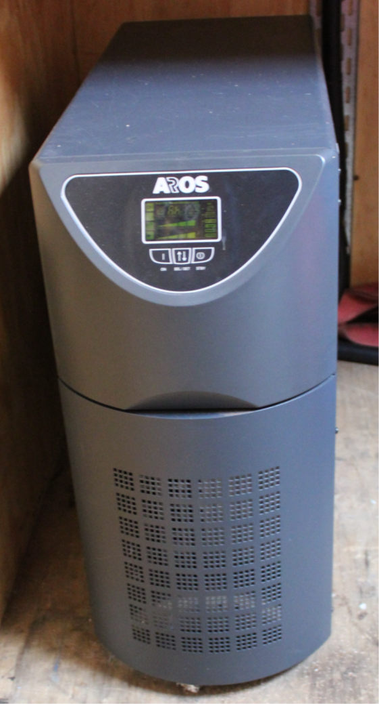

Figure . Small UPS located in the radar hut's lobby.

The distribution board is in the radar hut but shouldn’t be tampered with by anyone other than the base electrical engineer or a certified electrician.

## Radar Parts

Spare parts for the radar that should be kept in the radar hut include the following:

* Spare rope for stay ropes and antennas.
* Thin coaxial cable the antennas are made of.
* Coaxial antenna cable that connects the antennas to the radar hut.
* A set of at least 4 spare antenna halves.
* Any other components needed to make more antenna halves.

Spare parts for the transceiver boxes can be kept in the radar hut if the servicing station was moved there for the winter, however they should be in the base if that is where radar boxes are being serviced.